What Can We do to support the 16 Days of Activism?

- Pray! Put up a prayer globe or map in Church and join in with members all over the world by praying in your congregations. Take a photo and post on social media.
- Speak to your church Congregation or local groups to raise awareness.
- Give out leaflets or information - Spread the word
- Hold a service in Church.
- Send a press release to your local paper, your parish newsletter or your Church news letter.
- Write to your MP outlining your local, national or international concerns.
- Hold a vigil. Meditate or have prayer points around the Church. A globe or map of the world can help concentrate your prayers. Play soft reflective music, light candles, read from the Bible.
- Take a prayer walk around your parish. Start and finish at your Church (at your prayer globe or map) as you walk ask the spirit to lead you and you will find much that needs your prayer.
- In your Branch ask members to collect news clippings about GBV put up a board covered in these and use it to guide your Branch worship and discussions
- Wear a ribbon (or two) on your lapel. Yellow and purple are the campaign colours; white is for peace and non violence and blue for Mothers' Union.
- Use social media to publicise the campaign.

What have our members done in the past?

In the Democratic Republic of the Congo, Mothers’ Union members work closely with survivors of sexual violence (as a result of conflict) by providing emotional support, meeting basic needs such as housing, and equipping them with skills to become economically empowered.

Many Branches lit candles and held silent vigils
or prayer meetings.

Members in Taunton and Axbridge put up prayer trees and added prayers throughout the 16 Days.

In Kenya, Mothers' Union has carried out extensive work on raising awareness of female genital mutilation and supporting those who have experienced it and those who are at risk.

Members in Hereford circulated information about the 16 days Campaign to the local council.

In Burundi and Uganda members marched and held awareness days to inform about GBV

Information:

Mothers Union
Flourish House
2 Cathedral Avenue
WELLS
BA5 1FD

Tel: 01749 685131
Email: mu@bathwells.anglican.org
Website: www.mubathandwells.org

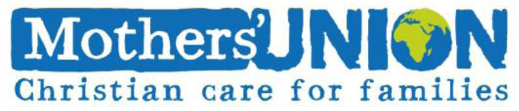
Diocese of Bath and Wells

The 16 Days campaign was instigated in 1991 and is co-ordinated by the Centre for Women's Global Leadership.

Mothers Union has campaigned against gender based violence (GBV) and for gender equality for many years in local national and international platforms so it is no surprise that we support the 16 Days of Activism Against Gender Based Violence. Our members across the world have supported this campaign in their own countries and since 2013 the whole Mothers' Union has been taking part.

The campaign is an extension of the day-to-day grass-roots work of Mothers’ Union. We work alongside communities to help end gender-based violence and to support those affected by it, every day of the year.

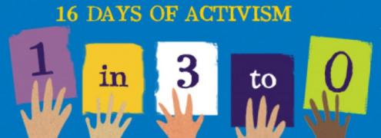

The 16 Days include some significant dates that we can mark with prayer and other action:

25th November – International Day Against Violence Against Women.
29th November – International Women Human Rights
Defenders Day.
1st December – World Aids Day
6th December – The Anniversary of the Montreal
Massacre. The day a crazed gunman, with
a hatred for women, targeted female
students at Montreal University.
10th December – International Human Rights Day.

The campaign works by:

- raising awareness about gender based violence as a human rights issue at local, national and international levels.
- Strengthening local work around violence against women.
- Establishing a clear link between local and international work to end this violence.
- Providing a forum in which organisers can develop and share new and effective strategies.
- Demonstrating the solidarity of women around the world standing against gender based violence.
- Creating tools to pressure governments to implement promises made to eliminate gender based violence.

End Gender-Based Violence in the Workplace

This year activists across the world will be raising awareness about the extent of gender-based violence in the world of work.
Worldwide, gender-based violence in the workforce is aggravated by existing social, structural, and legal factors that perpetuate gender segregation and inequity in the labour force. It is also made worst by negative stereotypes about women workers, and lack of women in top management posts.

With around 50% of women experiencing sexual harassment at work in the UK, as well as 70% of those affected by domestic abuse being targeted in their workplace, it’s evident that employers have much to do. They can use the 16 Days to engage with their employees and make them aware of policies and procedures in place to protect them against abuse, assault and harassment. If these policies are not currently in place, their existence essential.

Raise Awareness!

Did you know that...
• At least one in three women globally will experience some form of gender-based violence at some point in their lifetime (World Health Organisation).
• More than 700 million women alive in the world today were married as children (UN Women).
• In 2012, one in two women killed in a homicide was killed by a partner, former partner, or family member. One in 20 men was killed by a partner, former partner, or family member in this same year (UN Women).
• 4.5 million people worldwide are victims of forced sexual exploitation. 98% of these are women (UN Women).
• 133 million women and girls alive today are survivors of female genital mutilation (FGM) (UN Women).
• Globally, women between the ages of 15 and 44 are more likely to be maimed or die as a result of male violence than through cancer, malaria, traffic accidents or war combined (Restored).
• In England and Wales seven women a month are killed by a current or former partner (ONS Wales 2015 Crime Survey England and Wales)
• Every year 60 million girls are sexually assaulted at, or on their way to, school (Actionaid)

